**TABLE OF CONTENT**

|  |  |  |
| --- | --- | --- |
| **CHAPTER NO** | **TITLE** | **PAGE NO** |
| **1** | **INTRODUCTION** |  |
|  | 1.1 PROJECT OVERVIEW |  |
|  | 1.2 PURPOSE |  |
| **2** | **LITERATURE SURVEY** |  |
|  | 2.1 EXISTING PROBLEM |  |
|  | 2.2 PROBLEM STATEMENT DEFINITION |  |
| **3** | **IDEATION & PROPOSED SOLUTION** |  |
|  | 3.1 EMPATHY MAP |  |
|  | 3.2 IDEATION & BRAINSTORMING |  |
|  | 3.3 PROPOSED SOLUTION |  |
|  | 3.4 PROBLEM SOLUTION FIT |  |
| **4** | **REQUIREMENTS ANALYSIS** |  |
|  | 4.1 FUNCTIONAL REQUIREMENT |  |
|  | 4.2 NON-FUNCTIONAL REQUIREMENT |  |
| **5** | **PROJECT DESIGN** |  |
|  | 5.1 DATA FLOW DIAGRAMS |  |
|  | 5.2 SOLUTION & TECHNICAL ARCHITECTURE |  |
|  | 5.3 USER STORIES |  |
| **6** | **PROJECT PLANNING & SCHEDULING** |  |
|  | 6.1 SPRINT PLANNING & ESTIMATION |  |
|  | 6.2 SPRINT DELIVERY SCHEDULE |  |
|  | 6.3 REPORTS FROM JIRA |  |
| **7** | **CODING & SOLUTIONING** |  |
|  | 7.1 FEATURE 1 |  |
|  | 7.2 FEATURE 2 |  |
| **8** | **TESTING** |  |
|  | 8.1 TEST CASES |  |
|  | 8.2 USER ACCEPTANCE TESTING |  |
| **9** | **RESULTS** |  |
|  | 9.1 PERFORMANCE METRICS |  |
| **10** | **ADVANTAGES & DISADVANTAGES** |  |
| **11** | **CONCLUSION** |  |
| **12** | **FUTURE SCOPE** |  |
| **13** | **APPENDIX** |  |
|  | 13.1 SOURCE CODE |  |
|  | 13.2 GITHUB & PROJECT DEMO LINK |  |
| **14** | **REFERENCES** |  |

# 

# CHAPTER 1

# INTRODUCTION

**1.1 PROJECT OVERVIEW**

Natural disaster occurs, users in social media, sensors, cameras, satellites, and the like generate vast amounts of data. Emergency responders and victims use this data for situational awareness, decision-making, and safe evacuations. However, making sense of the generatedinformation under time-bound situations is a challenging task as the amount of data can be significant, and there is a need for intelligent systems to analyze, process, and visualize it. With recent advancements in Artificial Intelligence (AI), numerous researchers have begun exploringAI, machine learning (ML), and deep learning (DL) techniques for big data analytics in managing disasters efficiently. This paperadopts a systematic literature approach to report on the application of AI, ML, and DL in disaster management. Through a systematic review process, we identified one relevant hundred publications. After that, we analyzed all the identified papers and concluded that most of the reviewedarticles used AI, ML, and DL methods on social media data, satellite data, sensor data, and historical data. The most common algorithms are support vector machines (SVM), Naïve Bayes (NB), Random Forest (RF), Convolutional Neural Networks (CNN), Artificial neural networks. The proposed model works in two blocks:Block-I convolutional neural network (B-I CNN)

**1.2 PURPOSE**

Natural disasters not only disturb the human ecological system but also destroythe properties and critical infrastructures of human societiesand even lead to permanent change in the ecosystem. Disaster can be caused by naturally occurringevents such as earthquakes, cyclones, floods, and wildfires. Many deep learning techniques have been applied by various researchers to detect and classify natural disasters to overcome losses in ecosystems, but detection of natural disasters still faces issues due to the complex and imbalanced structures of images.

To tackle this problem, we developed a multilayered deep convolutional neural network model that classifies the natural disasterand tells the intensity of disaster of natural. The model uses an integrated webcam to capture the video frame and the video frame is compared with the Pre-trained model and the type of disaster is identified and showcased on the OpenCV window.

The impacts are high on the development agenda. Efforts to reduce or mitigate the impacts of disastersare increasingly focusedon exposure and vulnerability of human populations rather than just the nature of the hazard.There are a range of measures that can be taken to protect public health, based around these four aspects.

**CHAPTER – 2**

# LITERATURE SURVEY

**2.1** **EXISTING PROBLEM**

Natural disasterscan cause great damage on the environment, property, wildlife and human health. These events may include earthquakes, floods, hurricanes, tornadoes, tsunamis, landslides, wildfires, volcanic eruptions, and extreme temperatures.

Natural disasters kill tens of thousandseach year. If we look at the average over the past decade, approximately 45,000 people globally died from natural disasters each year. This represents around 0.1% of global deaths.Disasters are serious disruptions to the functioning of a community that exceed its capacity to cope using its own resources. Disasters can be caused by natural, man-madeand technological hazards, as well as various factors that influence the exposure and vulnerability of a community.

* + 1. To monitor pollution, ecosystem destruction and natural disaster on large- scale dynamically and around the clock- Generalized signal and channelalgorithm and parameter acquisition.
    2. It represents a model of risk assessment of urban drought which integrates hazard, exposure, vulnerability and emergency responseand recovery capability.

## 2.2 PROBLEM STATEMENT DEFINITION

Analyzing the changes in the environment that it cannot be predictable because the changes in the environment happened suddenly. To save the peoples from the disaster damages some times people are not supporting the rules given by the government people are felt nervous in the period of natural disasters.

|  |  |  |  |  |
| --- | --- | --- | --- | --- |
| I am | I’m trying to | But | Because | Which makes me feel |
| Researcher | Analyze the changes in the environment. | Sometimes it cannot be predictable. | Because the changes in the environment happened suddenly. | Guilty |
| People | Prevent from the damages by the disaster. | We can’t do anything. | Economic Level | Culpable |
| Government | Save the peoples from the disaster damages. | Sometimes people are not supporting the rules given by the government. | People felt nervous in the period of natural disasters. | Worried |
| Socialist | Help  the peoples in the period of disasters. | But we can’t serve for all the peoples who are in need. | Lot of people are affected during the disasters period. | Nervous |

# 

# CHAPTER - 3

# IDEATION & PROPOSED SOLUTION

**3.1 EMPATHY MAP CANVAS**

It is mainly used as user friendly which it makes an accuracy is good and it can be predict what is going to happen for future prediction. It preventing the loss of human lives and AI is used to communicate directlywithout the usage of the network. Drones and robot is used to locate survivors and it is used to transmit the information.

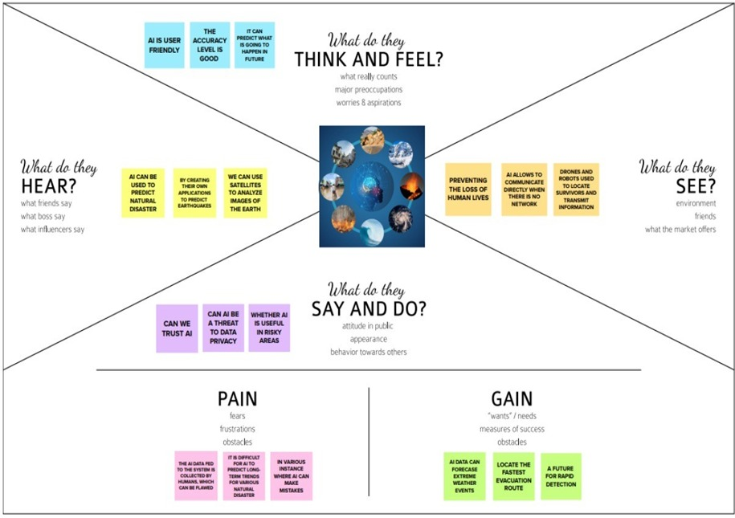

**Figure 3.1** Empathy Map

**3.2 IDEATION & BRAINSTORMING**

Brainstorming is a method of generating ideas and sharing knowledge to solve a particular commercial or technical problem, in participants are encouraged to think without interruption.Brainstorming is a group activity where each participant shares their ideas as soon as they come to mind.

**STEP 1 - BRAINSTORMING AND IDEA PRIORITIZATION**

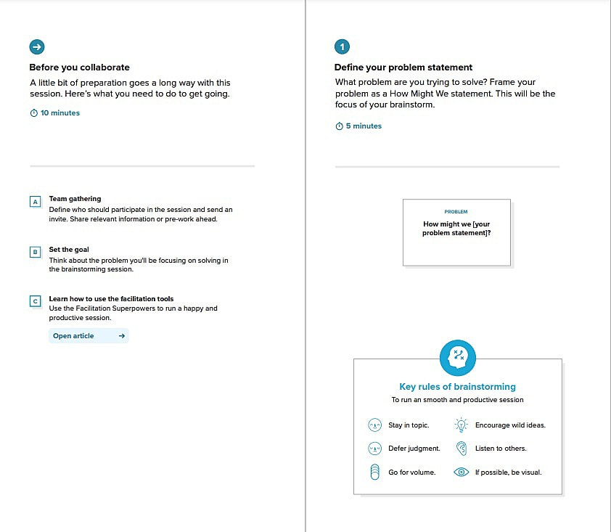

**Figure 3.2** Ideation and Brainstorming

**STEP 2 - BRAINSTORM, IDEA LISTING AND GROUPING**

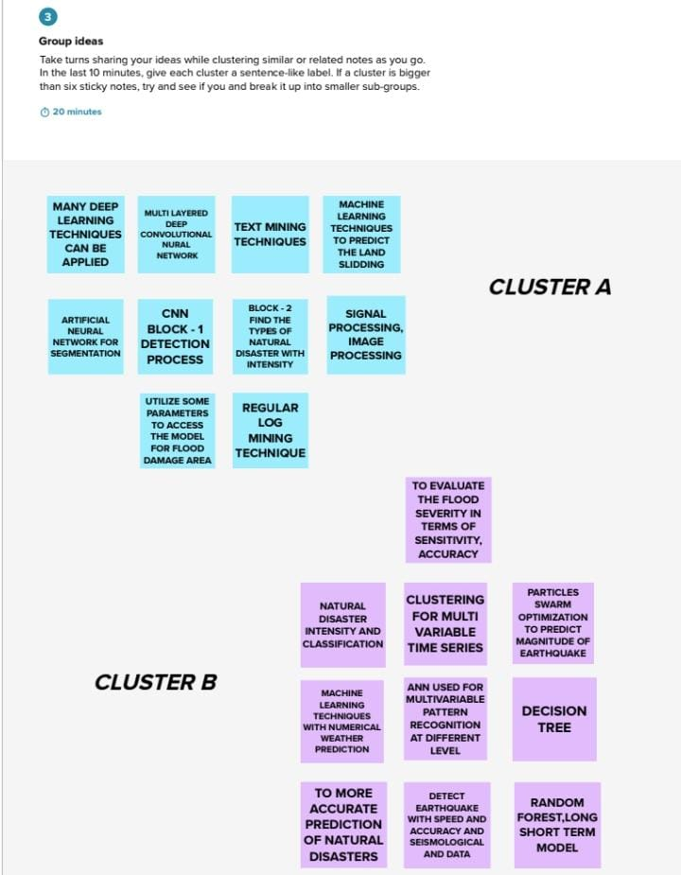

**Figure 3.2** Brainstorm, Idea Listing and Grouping

**STEP 3 - IDEA PRIORITIZATION**

## 

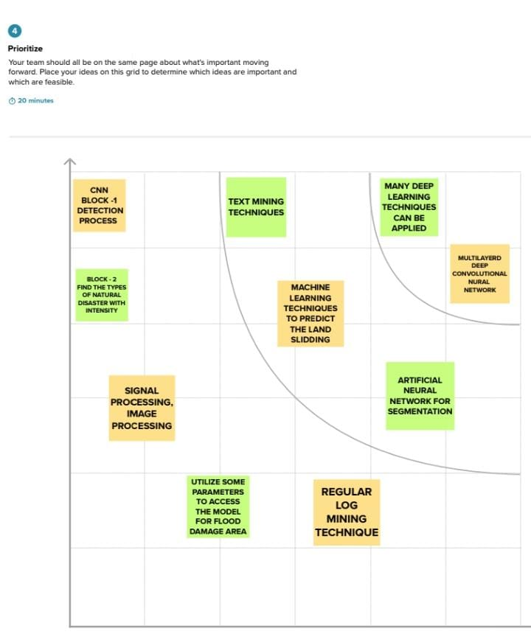

**Figure 3.3** Idea Prioritization

**3.3** **PROPOSED SOLUTION**

Natural disaster intensity and effect analysis using Artificial intelligence the parameter of problem statement. Nature-based solutions to disasters,Climate change is increasing the frequency, intensity and magnitude of disasters, leading to a higher number of deaths, injuries and increased economic losses.The techniques applied are: deep learning, artificial neural network and machine learning techniques. It is based on multispectral images using a multi-layered deep convolutional neural network. AI data can forecast extreme weather events. Locate the fastest evacuation route.

|  |  |  |
| --- | --- | --- |
| **S No.** | **Parameter** | **Description** |
| 1 | Problem Statement (Problemto be solved) | Natural disaster intensity and effect analysis using Artificial  intelligence. |
| 2 | Idea / Solution description | The techniques applied are:  deep learning, artificial neural network for segmentation and machine learning techniques. |
| 3 | Novelty / Uniqueness | It is based on multi spectral images using multilayered deep convolutional neural network. |
| 4 | Social Impact / Customer Satisfaction | AI data can forecast extreme weather events. Locate the fastest evacuation route. It is a future for rapid detection. |
| 5 | Business Model (Revenue Model) | We give a solution to the natural disaster intensity and effect analysis. |
| 6 | Scalability of the Solution | AI algorithms could instantaneously  assess flooding, building and road damage based on satellite images and weather forecasts. |

**3.4 PROBLEM SOLUTION FIT**

|  |  |
| --- | --- |
| **CUSTOMER SEGMENT**  AI data can forecast extreme weather events. Locate the fastest evacuation route. It is a future for rapid detection. | **JOBS-TO-BE-DONE / PROBLEMS**  Natural disaster intensity and effect analysis using Artificial intelligence. |
| **TRIGGERS**  Natural Disaster, also referred to as natural hazards are extreme, sudden events caused by environmental factors such as storms, floods, droughts, fires,and heat waves. | **EMOTIONS: BEFORE/ AFTER**  BEFORE:The disaster, a positive association was found between place- identity and well being, indicating that the stronger emotions participants evolved to the place.  AFTER: Accordingly, participants almost lost their emotional bond to the area but maintained their memories and thoughts about the site intact and, by that, their positive well being associations with the locations. |
| **AVAILABLE SOLUTIONS**  Aritificial Intelligence  algorithms could instantaneously assess flooding, building and road damage based on satellite images and weather forecasts,allowing resources to distribute emergency aid more effectively and identify those still in danger and isolated from escape routes. | **CUSTOMER CONSTRAINTS**  According to the Decision, the intensity of each type of disaster has been classified a maximum of 5 levels which are presented by 5 different colours, including: Level 1 with light blue indicates light intensity of risk; Level 2 with light yellow indicates medium intensity; Level 3 with orange indicates significant. |
| **BEHAVIOUR**  Natural disasters are traumatic events and it is thus likely that they affect individuals behavior in the short and possibly longer term. | **CHANNELS of BEHAVIOUR**  ONLINE What kind of actions do customers take online? Extract online channels.  OFFLINE What kind of actions do customers take offline? |
| **PROBLEM ROOT CAUSE**  Causes for such calamities can be contributed to deforestation, soil erosion, and pollution. | **YOUR SOLUTION**  Nature based solutions, such as conserving forests, wetlands and coral reefs, can help communities prepare for, cope with, and recover from disasters, including slow-on set events such as drought. |

**CHAPTER - 4**

## REQUIREMENT ANALYSIS

## **4.1 Functional Requirements:**

Disaster management is a challenging but highly rewarding career. disaster management coordinates the responses to major disasterssuch as floods, earthquakes, wildfires and terror attacks whilst minimizing the impact on those affected. It is skilled work needing significant expertise. If you want to get into disaster management, there are a number of key requirements you should meet. Maintain customer serviceby minimizing disruptions of business operations Protect facilities, physicalassets and electronic information.

|  |  |  |
| --- | --- | --- |
| **FR No.** | **Functional**  **Requirement (Epi c)** | **Sub Requirement**  **(Story/Sub-Task)** |
| FR-1 | **User Requirements** | Awareness of disasters,    Guidelines about disaster management ,    Clear note about the disasters. |

|  |  |  |
| --- | --- | --- |
| FR - 3 | **UserConfirmation** | Confirmation via Phone  Confirmation via Email  Confirmation via OTP |
| FR - 4 | **Payment Options** | CashonDelivery  Debit Card/Credit Card Net Banking,Paytm  Wallet and UPI |
| FR - 5 | **Product Delivery and Installation** | Door Step Delivery Take Away Free installation |
| FR - 6 | **Product Feedback** | Through WebPage  Through Phone Calls  ThroughGoogle  Forms |

## 4.2 NON-FUNCTIONAL REQUIREMENTS

Non functional Requirements (NFRs) define system attributes such as security, reliability, performance, maintainability, scalability, and usability. They serve as constraints or restrictions on the design of the system across the different backlogs.It Have a clear and self-explanatory manual. Application has to be secured with two step authorization passwords and passkeys will be assigned as per the users need. Hardwarerequire a regularchecking and serviceSoftware may be updated periodically immediate alert is provided in case of any system failure. It depends on the patient's need and the user'scustomization. The product has to cover all the space of isolation wards irrespective of the siz or area of a medical field.

|  |  |  |
| --- | --- | --- |
| **FR NO.** | **Non-**  **Functional Require ment** | **Description** |
| NFR-1 | **Usability** | Have a clear and self explanatory manual.  Easier to use. |
| NFR-2 | **Security** | Application has to be secured with two step authorization, Passwords and pass keys will be assigned as per the users need. |
| NFR-3 | **Reliability** | Hardware requirea regular checkingand service Software may be updated periodically imme diate alert is provided in case of any system  failure. |
| NFR-4 | **Performance** | The application must have a good interface. The system provides acknowledgment in just one second once the 'patient's information is checked. |
| NFR-5 | **Availability** | All the features will be available when the user requires. It depends on the patient's need and the user's customization. |
| NFR-6 | **Scalability** | The product has to coverall the spaceof isolation wards Irrespective of the size or area of a medical field. |

# 

# CHAPTER - 5

**PROJECT DESIGN**

## **5.1 DATAFLOWDIAGRAM**

User, have to register for the application by entering my email,password,and confirming my password by using it can access by account/dashboard the use will receive confirmation email once then it have registered for the application by confirming the email & click confirm mail. Then it can also register through the application via Facebook by registering and accessing through the dashboard with Facebook Login.The other method is to register the application through the email and access through the dashboard with email Login.Then it can loged into the application by entering email& password to get into the dashboard.It can able to monitor the devices as well as the cloud servicesto contact customer care executive at any time.The user can get the alert message an dinstant environmental parameters by clicking the message box as well as the alarm systeminour industry.Theuser have to start the program by making the decision and signup that have to logged into the authentication by registration profile.The data collection for natural disaster have to predict the disaster by pressing or indicating it into the alert alert message an dinstant environmental parameter.

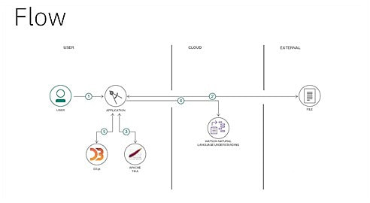

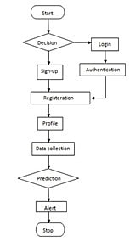

**5.2 SOLUTION & TECHNICAL ARCHITECTURE**

**TECHNICAL ARCHITECTURE**

Natural disasters not only disturb the human ecological system but also destroy the properties and critical infrastructures of human societies and even lead to permanent change in the ecosystem. Disaster can be caused by naturally occurring events such as earthquakes, cyclones, floods, and wildfires. Many deep learning techniques have been applied by various researchers to detect and classify natural disasters to overcome losses in ecosystems, but detection of natural disasters still faces issues due to the complex and imbalanced structures of images. To tackle this problem, we developed a multilayered deep convolutional neural network model that classifies the natural disaster and tells the intensity of disaster of natural The model uses an integrated webcam to capture the video frame and the video frame is compared with the Pre-trained model and the type of disaster is identified and show cased on the OpenCV windo

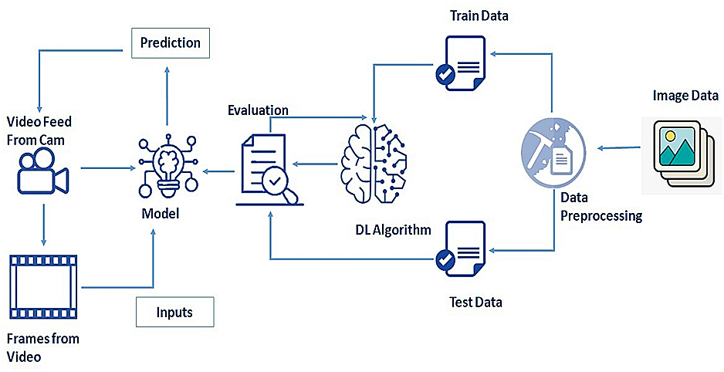

**SOLUTION ARCHITECTURE**

Solution architecture is the initial step taken when an organization aims to create a set of enterprise solutions, applications and processes that integrate with each other in order to address specific needs and requirements and that of en lead to software architecture and technical architecture work The solution architecture is described in a document that specifies acerta in level of vision for all current ad future solutions,applications and processes that the organization has design and development of solutions an applications then follow the guidelines specified in the solution architecture document to ensure that they conform to set standards that make integration and communication easier, and make the tracking of problems and in consistencies between well solutions easier as well.

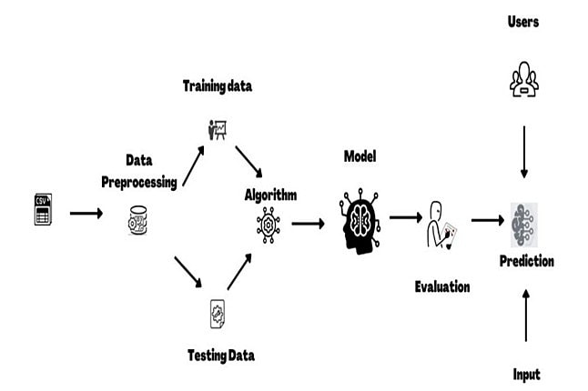

**5.3 USER STORIES**

|  |  |  |  |  |  |  |  |
| --- | --- | --- | --- | --- | --- | --- | --- |
| Sprint | Functional  Requirement | User  Story  Number | User Story/  Task |  | Story  Points | Priority | Team Members |
| Sprint-I | Registration | USN-I | As a user, I  can register for the  application by entering my email, password, and confirming my password. |  | 8 | High | Harini V |
| Sprint-I | Login | USN-2 | As a user, I can log into the application by entering email & password. |  | 8 | High | Soniya A |
| Sprint-2 | Data Sync | USN-6 | Syncing the data given to the website. | 3 | 8 | Medium | Sathish H |
| Sprint 3 | Enhancement Phase | USN-18 | Creating a Main web page. |  | 8 | High | Indhumathi A |
| Sprint-4 | Run the application | USN-19 | Connecting the frontend and backend using API. |  | 8 | High | Kavvya V |

# CHAPTER-6

## PROJECT PLANNING AND SCHEDULING

**6.1 SPRINT PLANNING ESTIMATION**

**SPRINT-I:**

Functional Requirement - Building HTML pages for login and Registration.

StoryPoints-8

Task1-Develop HTML and CSS for login and registration.

Task 2-Develop Java script code and attach to HTML

**SPRINT-II:**

Functional Requirement - Creation the main page and collecting data for image processing.

Story Points-7

Task1-Creating main page using HTML.

Task2–Collecting the dataset for image processing.

**SPRINT-III:**

FunctionalRequirement - Data Collection and Preprocessing.

Story Points-8

Task1–Taking pre-processing measures

for better data.

Task2– Image data generator.

Task3–Generating

**SPRINT-IV:**

Functional Requirement – Run the application.

StoryPoints– 8

Task1–Merge the frontend and back end

code.

Task2–Run the application.

## **6.2 SPRINT DELIVERY SCHEDULE:**

|  |  |  |  |  |
| --- | --- | --- | --- | --- |
| **SPRINT** | **DURATION** | **SPRINT**  **START**  **DATE** | **SPRINT**  **END**  **DATE(PLANNED)** | **SPRINT**  **END DATE(ACTUAL)** |
| Sprint1 | 03Days | 24Oct2022 | 26Oct2022 | 26Oct2022 |
| Sprint2 | 10Days | 27Oct2022 | 10Nov2022 | 10Nov2022 |
| Sprint3 | 02Days | 11Nov2022 | 09Nov2022 | 09Nov2022 |
| Sprint4 | 03Days | 10Nov2022 | 12Nov2022 | 12Nov2022 |

**6.3 REPORTS FROM JIRA**

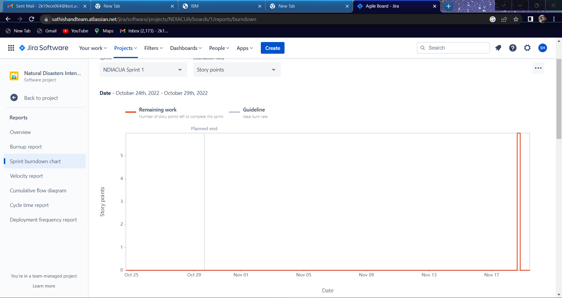

**VELOCITY REPORT**

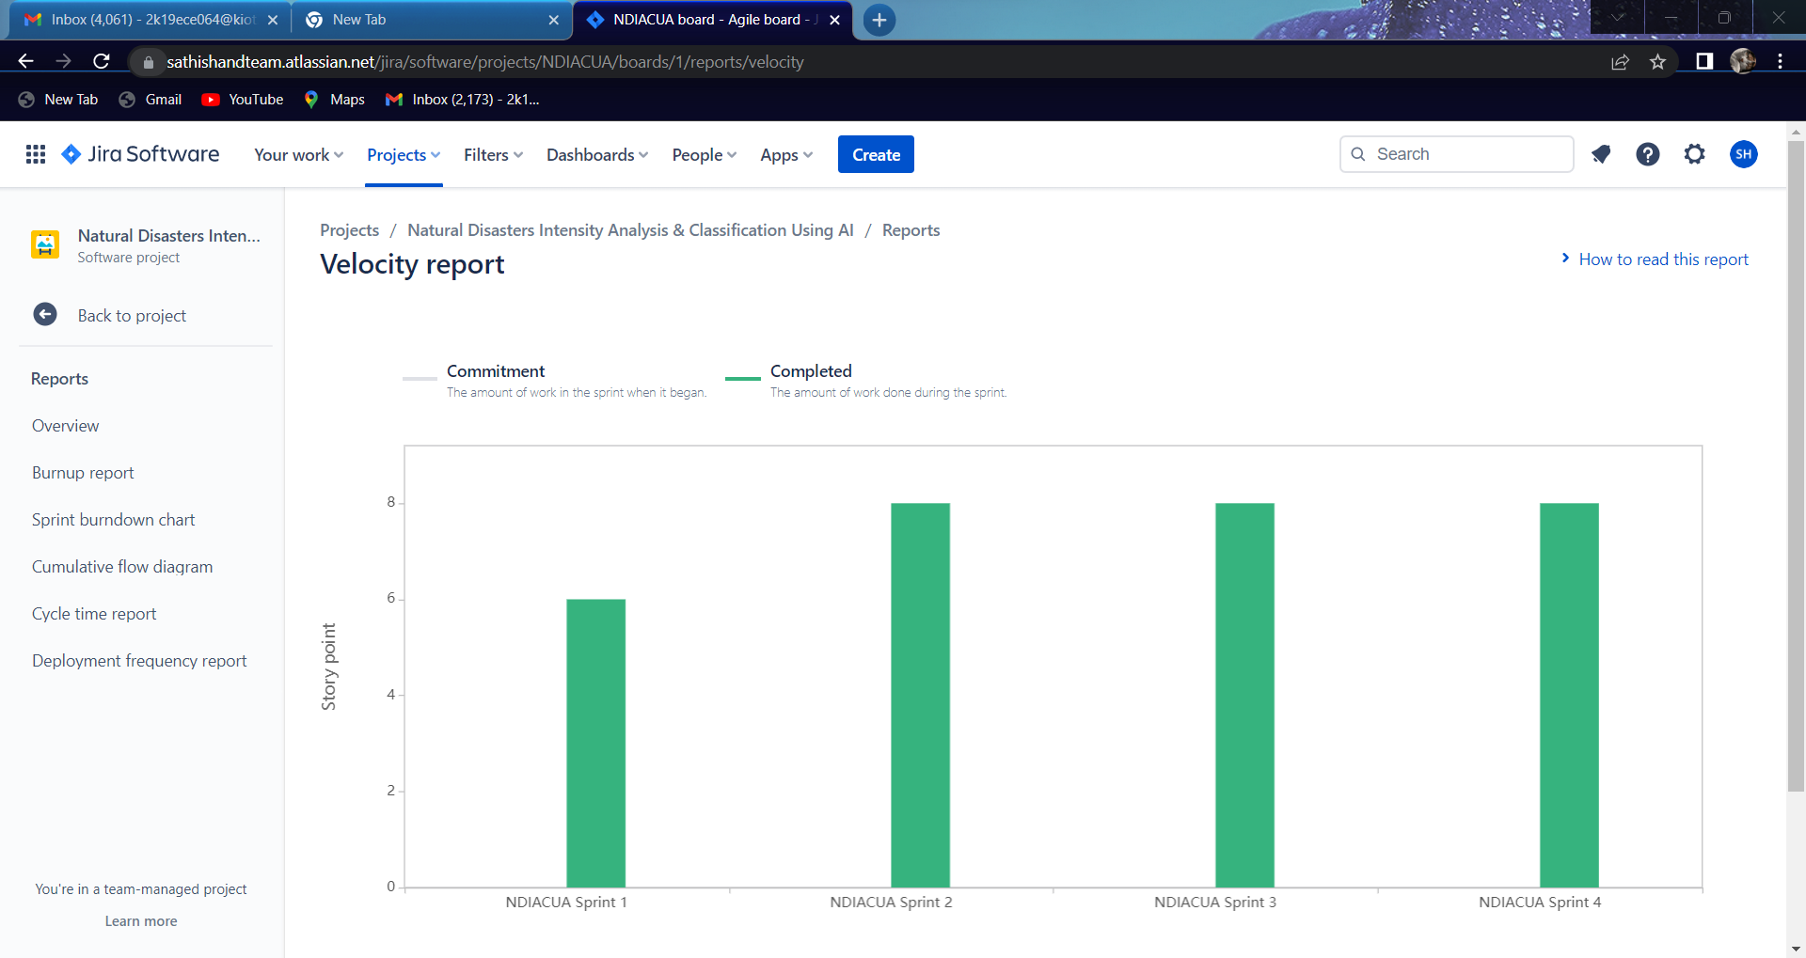

|  |
| --- |
|  |

# CHAPTER-7

## CODING AND SOLUTIONING

**7.1 FEAUTURE 1**

We have included the options like **weather widget** in our website.By this option we can know the temperature and weather report in our current location. The weather widget can display the current weather,a weather forecast for the next few gradients and no images are used.

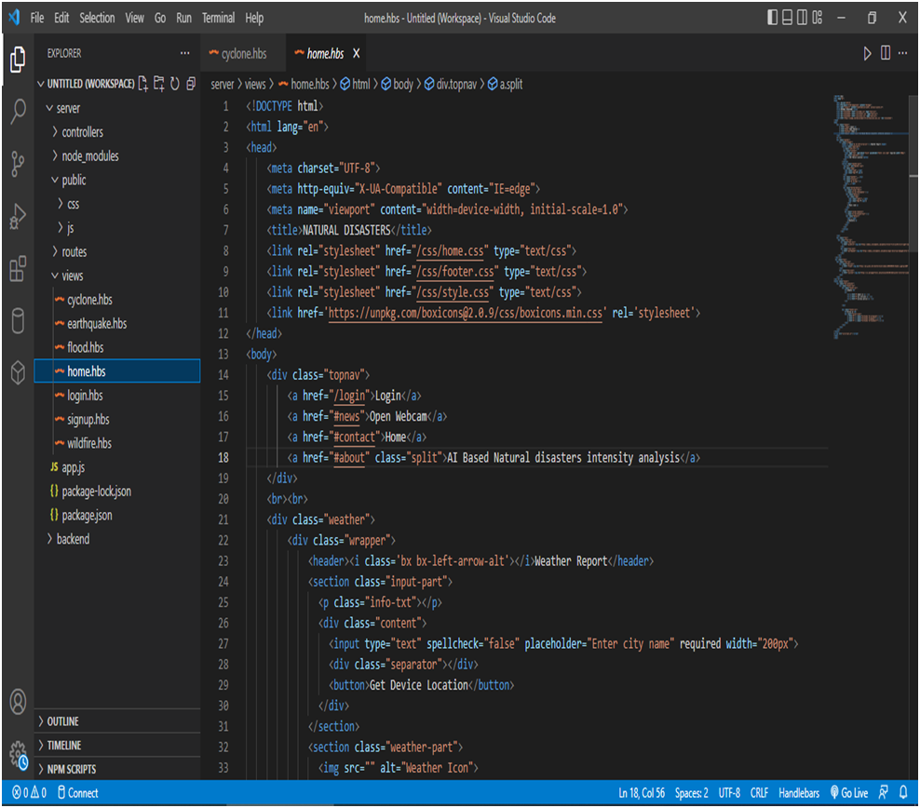

**FEATURE2: BACK-END**

We have developed a code for image processing.

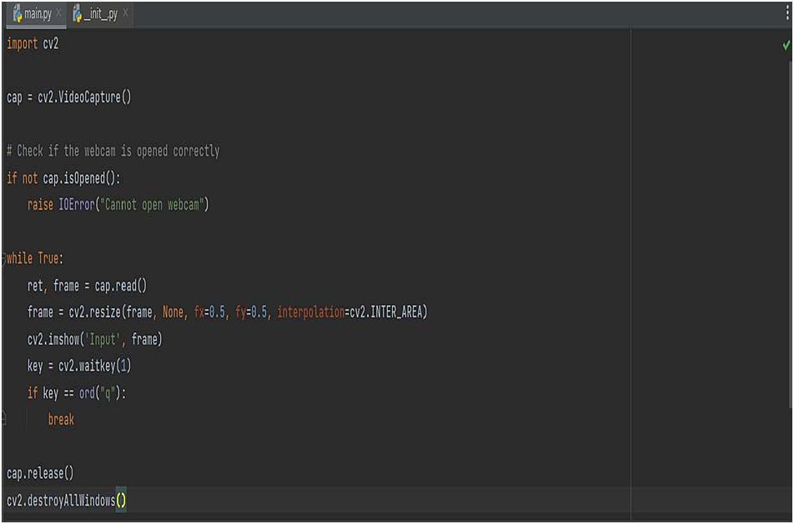

We have included the options like precautions in our backend code.By this option it will predictor intimate the precaution of the disaster.

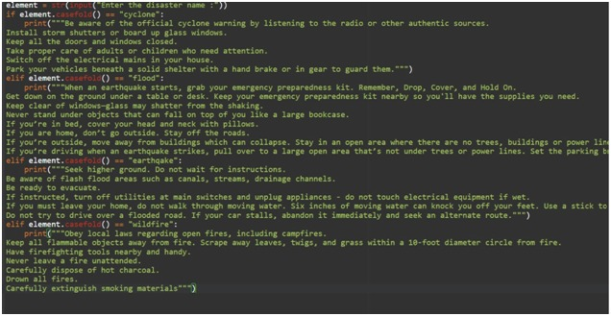We built a model for train set and test set using python flask.

# CHAPTER –8

## TESTING

**8.1 TESTCASE**

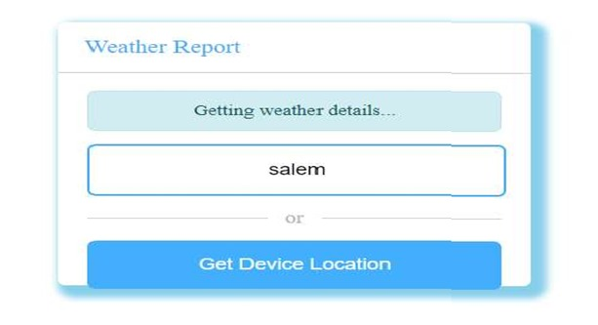

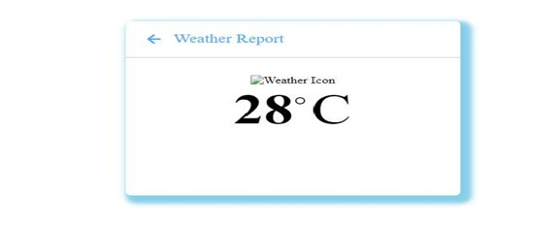

Outputforthemodelbuildingfortrainsetandtestsetusingpythonflask.

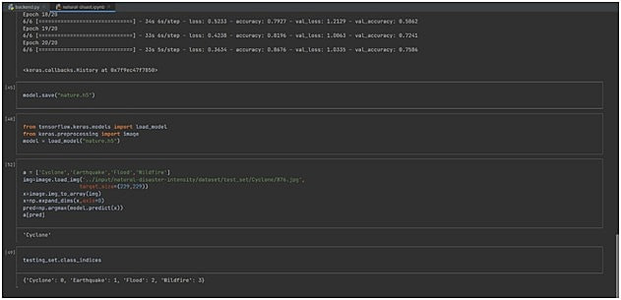

Outputfortheweatherprediction.

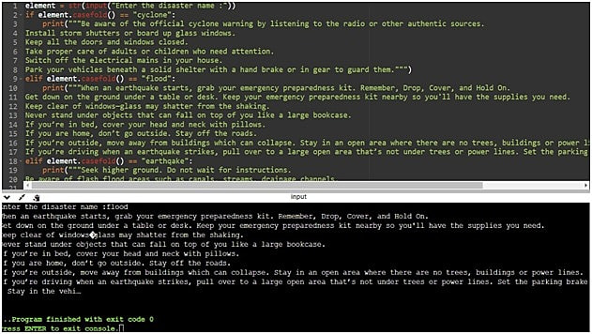

## LOGINPAGE

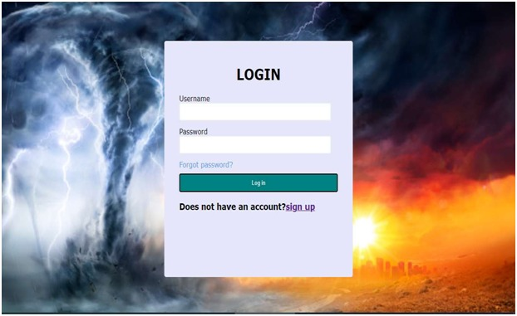

**SIGNUPPAGE**

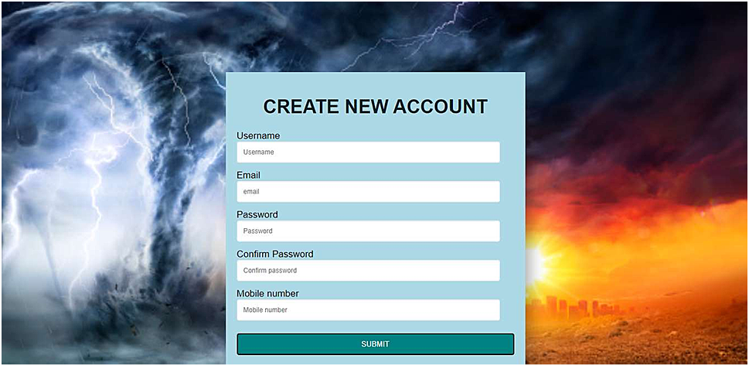

## 8.2 **USER ACCEPTANCE TESTING**

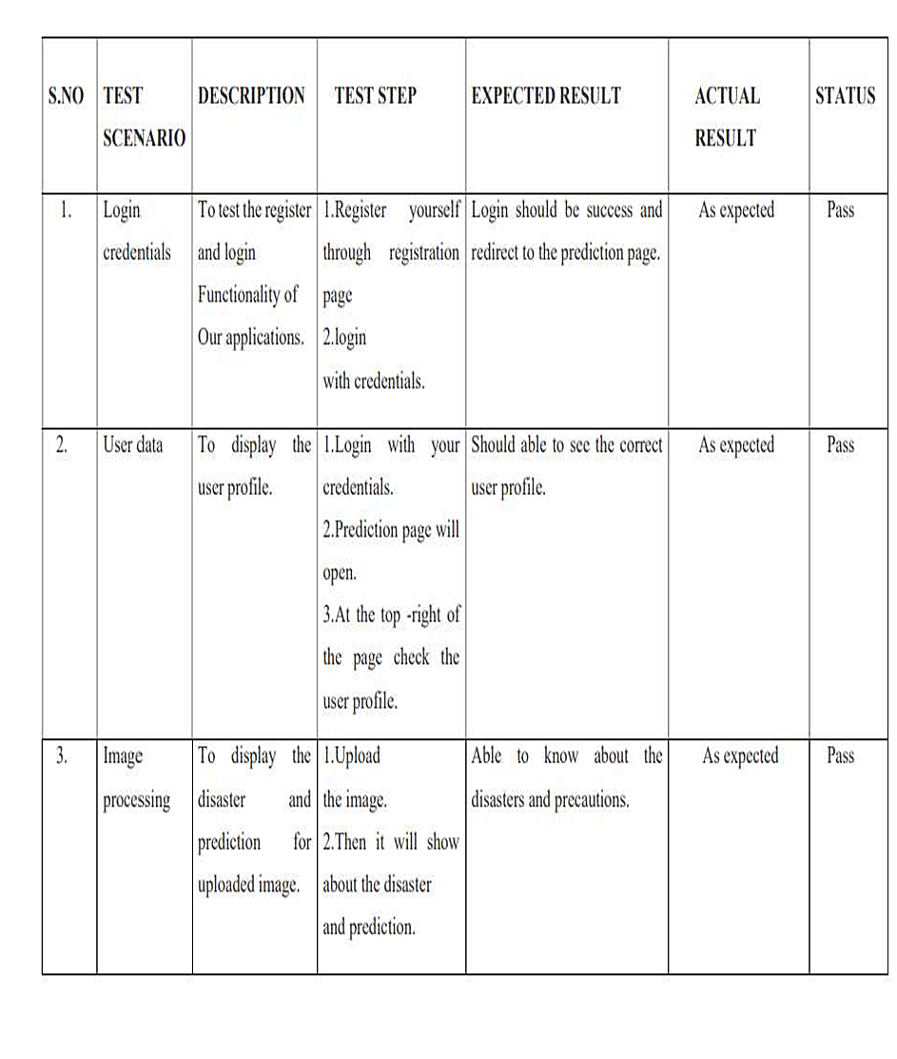

**CHAPTER–9**

**9.1** **PERFORMANCEMETRICES**

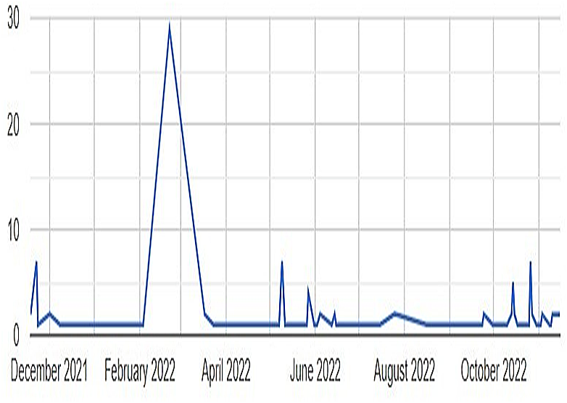

# CHAPTER–10

## ADVANTAGES AND DISADVANTAGES

**ADVANTAGE:**

1. Disaster management plays an integral role in keeping communities safe.

2. It involves coordinating the resources, such as pollution control systems, and responsibilities, such as following best practice policies, needed to prevent,prepare for,respond to,and recover from emergencies.

3. The wind will ca use top soil to be distributed to areas in which it

is lacking.

The property value and living conditions in some areas will improve through there development of infrastructure.

Hurricanes help to bring people together as they help each other in the after math.

## DISADVANTAG:

1. An area impacted by a natural disaster will show scars of the event for years to come

2. Loss of Life.

3. Damage to the Economy

4. Serious Environmental Change.

5. Injury or other health impacts

# CHAPTER-11

## CONCLUSION

It is the combination of the hazard along with exposure of a vulnerable societythatresultsinadisaster.Naturaldisasterscanbeaggravatedbyinadequatebuildingnorms,marginalizationofpeople,inequities,overexploitationofresources, extreme urban sprawl and climate change.Natural disasters, like floods,earthquakesorextremeclimateoutbreaks, severelychallengethehealthandwelfare of people, animals and the ecosystem. Natural disasters are catastrophiceventswithatmospheric,geological,andhydrologicaloriginsthatcancausefatalities,propertydamageandsocialenvironmentaldisruption.

Earthquakes shakethe groundsurface, cancause buildings tocollapse,disrupttransportandservices,andcancausefires.Theycantriggerlandslidesandtsunami. Earthquakes occur mainly as a result of plate tectonics, which involves blocks of the Earth moving about the Earth's surface.Natural disasters are catastrophic events with atmospheric, geological, and hydrological origins (e.g.,droughts,earthquakes,floods,hurricanes,landslides)that can cause fatalities,property damage and social environmental disruption.Disaster management is a process of effectively preparing for and responding to disasters.It involves strategically organizing resources to lessen the harm that disasters cause.It also involves a systematic approach to managing the responsibilities of disaster prevention,preparedness,response,and recovery.This is a plan that outlines what hazards your business is at risk of facing, what youcan do to avoid or manage them and how to get your business back up and running should a disaster strike. The conclusion of your disaster management planre iterates the salient points and provides action able take a ways.

|  |  |
| --- | --- |
|  |  |
|  |  |

|  |  |
| --- | --- |
|  |  |
|  |  |

|  |
| --- |
|  |

|  |  |
| --- | --- |
|  |  |
|  |  |